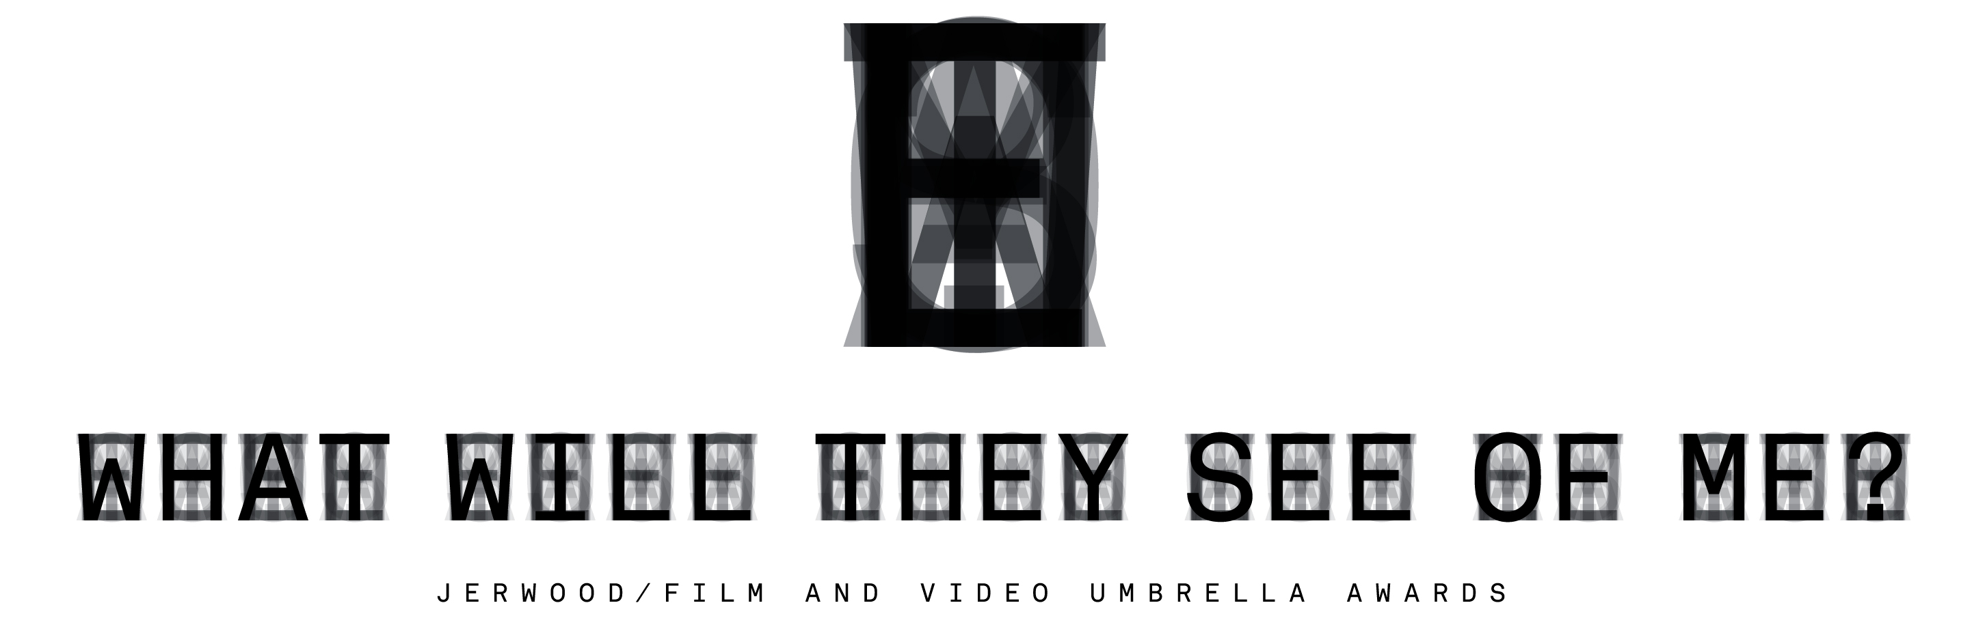

Press Release: For immediate release, Thursday 7 November 2013
Jerwood/Film and Video Umbrella Awards:
What Will They See of Me? unveils new artworks
by four rising stars in moving-image
Jerwood Space, London, 12 March – 27 April 2014
and
CCA: Centre for Contemporary Arts, Glasgow,
as part of Glasgow International, 4 – 21 April 2014
whatwilltheyseeofme.org.uk #WWTSOM

On 12 March, the four moving-image artists selected for the second edition of the Jerwood/Film and Video Umbrella Awards will premier new pilot works in an exhibition at Jerwood Space, London, before opening at CCA: Centre for Contemporary Arts, Glasgow on 4 April - as part of Glasgow International. This will mark the first time the Awards will feature in this world-renowned biennial festival of contemporary art.

The Jerwood/Film and Video Umbrella Awards are major awards for moving-image artists in the first five years of their practice, presented in partnership by Jerwood Visual Arts and Film and Video Umbrella, in association with CCA: Centre for Contemporary Arts, Glasgow. Earlier this year the shortlisted artists - Lucy Clout, Kate Cooper, Anne Haaning and Marianna Simnett – were awarded bursaries of £4,000 to allow them to research and develop new project ideas, with support from Film and Video Umbrella. Each artist has since responded to the curatorial brief and title ‘What Will They See of Me?’, with their four proposals exploring themes of identity, visibility and posterity in ways that both embrace and interrogate new technology and express a strong and compelling performative impulse.

The four artists were selected from a list of over 150 submissions by a panel of six experts in the field: artist Ed Atkins, who was previously selected for the first edition of the Jerwood/Film and Video Umbrella Awards; Steven Bode, Director of Film and Video Umbrella; Shonagh Manson, Director of Jerwood Charitable Foundation; Francis McKee, Director of CCA: Centre for Contemporary Arts, Glasgow; Sarah Williams, Jerwood Visual Arts Gallery Manager; and Catherine Wood, Curator of Contemporary Art & Performance at Tate Modern.

During the concurrent exhibitions in Glasgow and London next year, two of the four artists will be selected to receive a further £20,000 commission, enabling them to develop these initial ideas into finished works with further production support from Film and Video Umbrella. These completed pieces will then be exhibited once again at Jerwood Space, London, and then CCA: Centre for Contemporary Arts, Glasgow, in 2015.

The University of East London, School of Arts and Digital Industries, is generously supporting the Awards by providing the four artists with access to their wide range of facilities.

On the submission process and final selection, Steven Bode, Director of Film and Video Umbrella, commented:

‘The response to this new edition of the Jerwood/Film and Video Umbrella Awards indicates both the level of interest and the strength in depth of artists’ moving-image in the UK. The panel was struck by the breadth of talent and range of approaches to the project theme. We were especially excited by the proposals of the four artists selected, and we look forward to helping develop their projects over the next few months. It goes without saying that we will be seeing a lot more of these artists in the future…”

Lucy Clout

Lucy Clout’s project will investigate the background noise of modern communication, and those examples of so-called ‘minor speech’ that are everywhere around us but do not always capture our attention. As if to remind us that it is often the casual, off-guard remark that lingers longest in the memory, she will look more closely at some of the more peripheral aspects of our contemporary technological vernacular, and look back at how some of the overlooked products of earlier eras have acquired a strange, unruly afterlife.

Lucy Clout’s previous work has investigated the experience of viewing performance, interrogating the communicative aspects of the physical and social relationships between the audience and the art-object/performer. She graduated from the Royal College of Art with an MA in Sculpture in 2009, and has exhibited in commercial and non-commercial spaces in the UK and internationally. Recent solo exhibitions include International Project Space, Birmingham and Limoncello, London.

Kate Cooper

Kate Cooper is interested in how our everyday performance is produced online and how in turn this might relate to ideas of gender. What are the new forms of agency now available as we edit and post produce an online archive of our own bodies? Her project investigates the potential for self-invention that our relationships to our own images produce and the complex ways in which images of the self are used to accrue a new kind of ‘capital’.

Kate Cooper is an artist and co-founder of London-based artist-run initiative Auto Italia, which she began in 2007, after graduating from Central Saint Martins. She has exhibited in the UK and internationally including screenings and performances at Tate Modern, ICA and Artissima Art Fair. Cooper frequently undertakes collaborative projects, working with multiple other artists, and the Jerwood/Film and Video Umbrella Awards will be one of her first solo endeavours.

Anne Haaning

Anne Haaning’s project considers the marks we inadvertently leave in digital space and the records that we choose to make to document personal journeys. Alluding to the shifting sands of the desert, and the backdrop of a mythological historical past, her proposed work will experiment with the idea of digital ghosts, whose identity and meaning is forever changing, and who will eventually outnumber and outlive us.

Originally an MA graduate in Architecture, Anne Haaning will graduate from her MFA in Fine Art from Goldsmiths in 2014. She has been exhibiting in group shows internationally since 2009, and will have a solo exhibition at the Kunsthal Charlottenborg, Copenhagen in 2014.

Marianna Simnett

Continuing the interplay between animality and domestication that distinguishes much of her work, Marianna Simnett’s proposal revolves around the image of an udder as a symbol of innocence and abundance. All is not quite what it seems, however, as the piece develops into a wider reflection on our desire for pristine, virginal images of nature and our knowledge that these images, like milk itself, are not always inherently ‘natural’ but often the product of a complex system of technological manufacture.

Marianna Simnett graduated from the Slade School of Art with an MA in Fine Art Media in 2013. She has exhibited in group shows in the UK and internationally.

The exhibition will open at Jerwood Space, London from 12 March to 27 April 2014 and at CCA: Centre for Contemporary Arts, Glasgow - as part of Glasgow International, from 4 to 21 April 2014. More information can be found at whatwilltheyseeofme.org.uk or by following @FilmVidUmbrella on Twitter (#WWTSOM).

- Ends -

For further information on the Jerwood/Film and Video Umbrella Awards, please contact Rachael Young at Four Colman Getty:
E: Rachael.young@fourcolmangetty.com
T: 020 3697 4257

Notes to editors

The Jerwood/Film and Video Umbrella Awards are major awards for moving-image artists in the first five years of their practice, presented in partnership by Jerwood Visual Arts and Film and Video Umbrella.

Project Credit: The Jerwood/Film and Video Umbrella Awards: What Will They See of Me, are a collaboration between Jerwood Visual Arts and Film and Video Umbrella in association with CCA: Centre for Contemporary Arts, Glasgow, and supported by University of East London, School of Arts and Digital Industries. Film and Video Umbrella is supported by Arts Council England

Film and Video Umbrella commissions, curates, produces and presents film, video and other moving-image works by artists that are staged in collaboration with galleries and other cultural partners. Since the late 1980s, Film and Video Umbrella has been at the forefront of this vibrant and expanding area of practice, promoting innovation through its support of some of the most exciting figures on the contemporary scene. During this time, the organisation has commissioned and produced over 100 different artists’ projects, ranging from ambitious multi-screen installations to shorter film and video pieces, as well as numerous online commissions. www.fvu.co.uk

Jerwood Visual Arts is a contemporary gallery programme of awards, exhibitions and events at Jerwood Space, London and on tour nationally. Jerwood Visual Arts supports and showcases the work of talented emerging artists. It aims to make connections and provoke conversations within and across visual arts disciplines and is a major initiative of the Jerwood Charitable Foundation. www.jerwoodvisualarts.org

The Jerwood Charitable Foundation is dedicated to imaginative and responsible revenue funding of the arts, supporting artists to develop and grow at important stages in their careers. It works with artists across art forms, from dance and theatre to literature, music and the visual arts. www.jerwoodcharitablefoundation.org

