Would you like to contribute to the development of one of the UK’s leading arts organisations specialising in film and moving-image media?
Film and Video Umbrella is seeking new trustees to join the existing board.

Application deadline: 26 November 2018

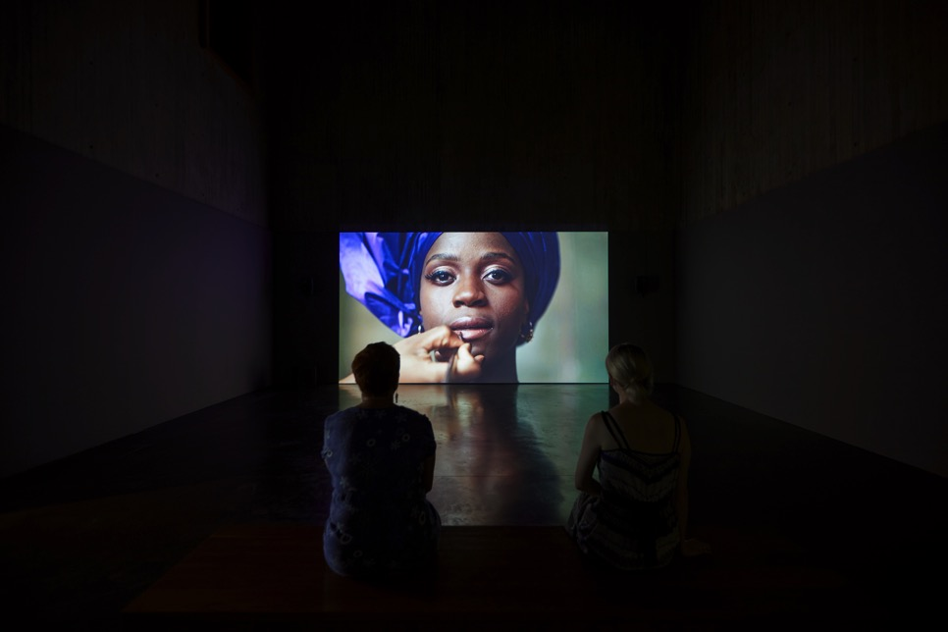
Hetain Patel, Don't Look at the Finger, installed at The New Art Gallery Walsall. Photographer David Rowan.
We are looking for up to four new trustees with expertise and extensive networks in the creative industries (especially digital and tech), fundraising, finance and business planning, and social media and marketing, to join our board as we prepare for a crucial period of growth and development. This is an opportunity to make a real difference and contribute to the success of a pioneering national arts organisation.
About FVU
For three decades FVU has led the way in championing new creative talent and promoting innovative ideas by contemporary artists working with the moving image. During that time, we have commissioned many of the foremost figures in the field, working in close collaboration with a diverse range of museums, galleries and other venues, nationally and internationally. To find out more, visit www.fvu.co.uk/projects
Funding and income generation
FVU is a registered charity. Core funding comes from Arts Council England as one of their National Portfolio Organisations. We raise the vast majority of our additional funding and income on a project-by-project basis, from trusts, foundations and exhibition venues. Currently, a relatively small proportion of our project funding comes from other sources such as educational bodies, corporate sponsorship, and individual donors, and we supplement our overheads via commercial activities such as consultancy, publication sales and equipment rentals.

New trustees

FVU is looking for up to four new trustees to help us to support, steer and develop the organisation’s work, ensuring we remain relevant and valuable to the artists and partner organisations we support, as well our funders and our audiences. The new trustees will join a pioneering and forward-facing organisation with an existing core of dedicated and engaged trustees. You will be able to make a substantial contribution towards helping us realise our vision of a thriving artists’ moving-image culture in the UK connecting meaningfully with the audiences of today. You will:
- Be part of ensuring we develop and deliver our vision/mission.
- Be able to give something back through supporting a pioneering arts organisation to achieve greater success through reaching more people in more ways right across the UK.
- Gain new skills, expand your networks and improve your own professional development.

Attributes of a trustee

- Commitment to the work of FVU and alignment with our values, vision and mission.
- Share our passion for, and commitment to, developing opportunities for new and established creative talent working at the forefront of moving-image culture today.
- Understanding of the legal duties, responsibilities and liabilities of trusteeship
- Ability to think and act strategically.
- Sound, independent judgment.
- An established reputation or profile with a willingness to use their contacts to advance the organisation’s mission.
- A preparedness to offer personal and professional skills and experience to support the work of the staff when required.

Roles and responsibilities
As a new trustee you will play an active and important role in the future of the charity and will work directly with the existing trustees and the leadership team of the organization, which includes the Director Steven Bode and Programme Development Director Susanna Chisholm. You will bring your experience and insights to support our future development and will be able to:
- Attend four board meetings a year
- Review papers and material that is provided in advance of meetings
- Provide advice outside of board meetings to the executive team and staff members around your particular areas of expertise, when needed
- Attend a number of FVU private views and launches, advocacy and networking events.
- Ensure the financial solvency of the company – approving budgets, monitoring, financial planning.

Specific knowledge and experience that we’re aiming to bring onto the board
We are seeking to appoint up to four individuals who will add to the knowledge, skills and diversity of our board. As part of this, we are looking for at least one trustee who is under 30 years of age, in order to keep the board representative of our target audiences, and who has some existing experience in the cultural sector.
We are also aiming for the board to reflect the diversity of the country in which we work, and are therefore seeking individuals from across the UK (we will cover travel to and from meetings for those based outside of London) as well as vitally, the cultural diversity of the UK.
We are specifically seeking individuals with expertise in one or more of the following areas:
- Fundraising – Knowledge and practical support for how FVU might increase its fundraised income and diversify its funding streams. Willingness to introduce FVU to personal contacts that may become donors or corporate supporters particularly welcomed.
- Social media and marketing, helping us to develop our profile and position within the world of contemporary art and culture.
- Creative industries (especially tech and digital) – insights, knowledge and perspective of how digital is transforming society, culture, communication and consumption, and the opportunities that this might provide for FVU.
- Finance and business planning – Knowledge and understanding of financial
strategy, business planning and managing change.
Join a dynamic and engaged group of existing trustees
- Eddie Berg - Chair, Chief Executive of Rich Mix, a multi-arts venue in the heart of London’s East End, former Director of Partnerships at BFI, and founder and CEO of FACT, Liverpool.
- Jon Armstrong, Head of Government and Parliamentary Relations at Heritage Lottery Fund, formerly Head of Cultural Strategy at Lambeth Council.
- Steven Bode, writer, curator and Director of FVU since 1992.
- Lawrence Lek, internationally acclaimed artist, previously commissioned by FVU.
- Kate Wilson, arts consultant, fundraiser and producer.
- Jason Wood, Artistic Director of Film at HOME, Manchester.
Practical details
Meetings are held in FVU’s office in Borough, London. This is an unpaid role. FVU will reimburse any travel expenses to meetings in full, including overnight accommodation if necessary. Our trustee meetings are always lively and full of debate. We aim to create a culture in which all of our trustees can contribute equally effectively, regardless of background or knowledge.
How to apply

Please send a CV, a brief covering letter (no more than two pages of A4) setting out why you’re interested in becoming a trustee and what you may be able to contribute, and a completed Equal Opportunities Monitoring Form (available below) to Eddie Berg, Chair of the Board of Trustees, FVU, 8 Vine Yard, SE1 1QL, or by email to: admin@fvu.co.uk.

Application deadline: 26 November 2018.

For an informal discussion about the trustee opportunities, and about FVU itself, please email Steven Bode, Director, FVU: steven@fvu.co.uk
More information about FVU and the board of trustees is available on our website at www.fvu.co.uk/about-us/staff-and-directors

All applications will be read by FVU's directors and two trustees, who will select a shortlist of applicants to invite for a chat. Successful candidates will then follow a short induction process before attending their first board meeting in the first quarter of 2019.
Thank you for your interest, we look forward to hearing from you.
Return to the FVU website.
Equal Opportunities Monitoring Form

We would be extremely grateful if you could respond to the following questions. These questions are optional, and you can tick ‘Prefer not to say’ or leave the answer space empty if you do not wish to give this information. Answers that you give will not affect your application to this opportunity.

We will process this data in its anonymous form to review the equality of opportunity or treatment between persons, with a view to enabling equality to be promoted and maintained, and for reporting and marketing analysis. Information will only ever be shared in its anonymous form in order to report to stakeholders, in particular Arts Council England.

Our full Privacy Policy is available on our website at www.fvu.co.uk/privacy-policy

Please provide us with information about yourself by circling or highlighting the answers that apply to you for each of the following questions:

1. How did you hear about this opportunity? (Please highlight all that apply)

- FVU website
- FVU e-bulletin
- FVU Facebook
- FVU Twitter
- FVU Instagram
- Advert (please state where you saw the advert)

- Via another organisation (Please state which)

- Via a friend or colleague

2. Did you attend university?

- Yes
- No
- Prefer not to say

3. Which age group are you within?

- 0-19
- 20-34
- 35-49
- 50-64
- 65+
- Prefer not to say

4. Which of the following best describes how you think of your gender identity?

- Female
- Male
- Non-Binary
- Prefer not to say

5. Do you identify as any of the following?

- Bisexual
- Gay man
- Gay woman
- Heterosexual
- Prefer not to say

6. What is your religion?

- No religion
- Christian (all denominations)
- Buddhist
- Hindu
- Jewish
- Muslim
- Sikh
- Any other religion (please specify)

7. What is your ethnic group? (The groups listed below match those used in the 2011 Census, so that we can make comparisons with the demographics of the population.)

- White: British
- White: Irish
- White: Gypsy or Irish Traveller
- Other White background*
- Mixed: White and Black Caribbean
- Mixed: White and Black African
- Mixed: White and Asian
- Other Mixed/multiple ethnic background*
- Asian or Asian British: Indian
- Asian or Asian British: Pakistani
- Asian or Asian British: Bangladeshi
- Asian or Asian British: Chinese
- Other Asian background*
- Black or Black British: African
- Black or Black British: Caribbean
- Other Black/African/Caribbean background*
- Arab
- Other*
- Prefer not to say

*What other?

8. Do you identify as having one or more of these disabilities?

- Visual impairment/Blind
- Hearing impairment/Deaf
- Physical disabilities
- Cognitive or learning disabilities
- Mental health condition
- Other long term health condition
- No, I do not have a disability
- Prefer not to say

9. Did you experience any significant barriers whilst submitting your application?
(For example, please tell us if you found the language clear and easy to comprehend, whether you would prefer to see the application requirements presented in another way, or whether you would find it helpful to apply in another way.)

- No
- Yes (please specify)

- Prefer not to say

Thank you

